March 24, 2022

Re: Manuscript ID GASTRO-D-21-02925

Dear Drs. Vaezi, Peek, and Corley:

Thank you to your staff and the reviewers for a critical review of our manuscript. We sincerely appreciate the constructive feedback to help improve our study: The Association between Proton Pump Inhibitor Exposure and Key Liver-Related Outcomes in Patients with Cirrhosis: A Veterans Affairs Cohort Study. We have done our best to address the reviewer comments and have incorporated changes into a substantially revised manuscript, which we have uploaded along with this point-by-point response. We hope that you now find this work suitable for publication in Gastroenterology, as we believe this represents important work to elucidate the potential impact of proton pump inhibitors on adverse outcomes in patients with cirrhosis.

Thank you again for your consideration and please do not hesitate to contact us with questions.

Sincerely,


Nadim Mahmud, MD MS MPH MSCE (corresponding)
Division of Gastroenterology, University of Pennsylvania
3400 Civic Center Blvd, Philadelphia, PA 19104
Email: nadim@pennmedicine.upenn.edu
Telephone: +1-215-349-8222

Responses to Editor and Reviewer Comments

Editorial Team
1. We thank the authors for their contribution. There is sufficient interest to evaluate a revised version addressing the comments by the reviewers. The main concern is observational studies is the causal inference and issue of confounding by indication. Can the authors balance their discussion with these concerns about their findings?

Response: Thank you very much for your careful consideration of our manuscript. In the revised manuscript, we now incorporate multiple additional primary and sensitivity analyses as recommended by the reviewers which we feel strengthens the observed findings with regard to PPI exposure and reduced mortality in patients hospitalized with GIB. We have also expanded the discussion and limitations sections to better acknowledge potential issues of selection bias, residual confounding, and inability to determine causality based on these findings. Please see specific responses to reviewer queries for expanded discussion and details on these changes.
Reviewer #1

1. This is a well-designed study, with a large number of subjects over a long time period (5 years) addressing an important area of clinical controversy.
Its use of complex statistics attempts to overcome problems of confounding which have caused difficulty in interpreting the results of other PPI safety studies.
It clearly demonstrates a harmful relationship between PPIs and liver- related outcomes (death, SBP, decompensation), including demonstrating a dose- response relationship.
Using sequential models, the authors demonstrate no impact of PPI on overall mortality, with an excess or liver- related mortality but less GIB related mortality.
It is unfortunate that the cause of death (liver vs non- liver) had to be estimated in the majority of cases.

Response: Thank you very much for your critical review of our manuscript. We agree that the inability to confirm all causes of death is a limitation. For this reason we flagged these analyses as “exploratory” in nature in the manuscript, and additionally highlighted this issue in the limitations section. We are hopeful that future studies in datasets with detailed cause of death data may be able to address this further.
2. For practicing clinicians, it would be useful to provide some additional information, or context in the discussion to convey the plausibility of this model. If there is an excess of deaths with PPI except when we take account of GI bleeding (GIB) GIB related deaths, a first impression is that the mortality related to GIB must be relatively high in this cohort, and that there must be a relatively high proportion of non- variceal to variceal bleeding for PPIs to be particularly effective.

Response: Thank you for raising this important point. This is an excellent suggestion, and we agree that further exploration of the interaction between PPI exposure and hospitalization with GIB is warranted, especially given the primacy of this finding to the manuscript overall. To address your critique, we have first returned to the dataset to classify the GI bleeding events as PUD versus non-PUD. We did not report this in the initial manuscript given that these GIB codes have not been validated to distinguish PUD from non-PUD GI bleeding in the VA cohort, and thus the reliability of this is not known. However, with that caveat in mind, there are dedicated ICD-9 and ICD-10 codes that are intended to be applied specifically for PUD related bleeding (531.x, 532.x, 533.x, 534.x; K25.x, K26.x, K27.x, K28.x). We have used these codes to classify PUD vs. non-PUD bleeding.

In the revised manuscript we have added several data points and relevant analyses. First, a total 11,998 (15.7%) of the cohort experienced a hospitalization with GIB. Of these, 3,079 (25.7%) were PUD-related GIB events. Second, we performed an additional exploratory analysis to determine whether the observed protective association between PPI exposure and all-cause mortality in patients with hospitalization GIB was likely to be related to management of PUD specifically. For this analysis, we limited hospitalization GIB events to only those with PUD as an etiology, and repeated final multivariable regression models. In all approaches to categorizing PPI exposure, we found an increase in the magnitude of the protective association between PPI exposure and all-cause mortality in patients with PUD-related GIB. This adds support to the hypothesis that the mechanism by which PPIs may be protective in this setting is through management and prevention of PUD-related complications. We have updated the methods, results, and discussion to reflect these changes.
3. It would be useful to have an indication of the proportion (or at least a discussion) of patients who were hospitalized for GIB, and the GIB mortality, and ideally an indication of the proportion of variceal versus non- variceal GIB, and whether PPI was harmful or protective in variceal GIB. The authors acknowledge that they do not have specific peptic ulcer data (line 58, page 2 of discussion)
Response: Thank you for raising this important point. We have done our best to address this line of inquiry in our response to your Query #2. Variceal bleeding events are difficult to reliably capture in this dataset given very poor sensitivity of the associated diagnostic codes. Instead we now provide the proportions of PUD and non-PUD-related bleeding, in addition to the dedicated PUD-related analysis detailed above. We have also expanded the limitations section to note that variceal bleeding could not be captured to explore the association between PPI exposure and mortality in this specific clinical scenario.
minor points:
4. Introduction, lines 5-9): altered metabolism/ pharmacokinetics may not be the main reason for PPI adverse effects in cirrhosis. It may relate to intended therapeutic effect on more susceptible individual (e.g. leaky gut)- as discussed by authors at line 52-3 in discussion. Might be better to say in introduction that both altered pharmacokinetics and intended therapeutic effect of PPI in susceptible individuals create biological plausibility for potentially harmful effects of PPI.

Response: Thank you for highlighting this issue. We agree with your recommendation and have made the association changes to the introduction.
Table 3 and Figure 2 provide the same information- one could be omitted.

Response: Thank you for this suggestion. As detailed in our responses to queries from reviewer #2, we have added results from additional regression analyses to Table 3, which are not reflected in Figure 2. In light of these changes, we have opted to include both Table 3 and Figure 2 as primary data in the manuscript. Figure 2 also provides a nice visual overview of the results which may be more difficult to appreciate in table format alone.
The information in supplementary table 4 is quite important and should perhaps be a main rather than supplementary table.

Response: Thank you for this suggestion. We agree that the data in Supplemental Table 4 are important to the paper. We have moved these data into a combined Table 2, which now also features results from an analysis of cumulative PPI dose exposure.
I would suggest mentioning the effect of increasing PPi dose on mortality in the abstract

Response: Thank you for raising this important point. We agree with your recommendation and have modified the abstract to reflect this.

Reviewer #2
Reviewer 2: This is an interesting study evaluating the association between PPI use and all-cause mortality as well as specific adverse outcomes in patients with cirrhosis.
1. It was not clear to me how the authors handled patients who were taking PPI for some of the follow up time but not at other time periods. I presume from the methods if they had not taken PPIs for 90 days they were classified as non-PPI users but how do you handle someone who took PPIs bid for 5 years but stopped 91 days before and then died versus someone who took a few days of PPI 25 days ago?
Response: Thank you very much for your detailed and excellent review of our manuscript, and for raising this critical point. We modeled PPI exposure as a time-varying covariate such that for each 1-month follow-up window, there was an indicator of patient PPI exposure, both in terms of binary exposure and omeprazole-equivalent dose exposure. Accumulated observations over time would contribute to effect size estimates for PPI use or non-use. However, you raise a very important point that this approach could miss effects of cumulative exposure and simultaneously potentially allow for residual confounding by indication. That is, if many patients are newly started on a PPI proximal to an outcome, this could still create a spurious association between exposure and outcome.

To address this critique and explore this issue, we have added regression analyses of cumulative PPI exposure for each outcome. We computed cumulative PPI exposure in terms of mg-months (omeprazole equivalents) and expressed estimates per 320 mg-months. The results were globally similar to the primary analyses, which lend further support to the study findings. In particular, in infection and decompensation outcomes models, cumulative PPI exposure was associated with an increasing hazard of each outcome. In the mortality models, we again identified a statistically significant interaction between cumulative PPI exposure and hospitalized GI bleed. Cumulative PPI exposure was associated with reduced mortality in patients with hospitalization for GI bleed (similar to the binary PPI exposure model), however in patients without hospitalization for GI bleed there was an increased association with mortality with cumulative PPI exposure (in contrast to the binary PPI exposure model). This suggests that the association between PPI exposure and all-cause mortality may rely on cumulative exposure rather than binary receipt of PPI medication. To reflect these changes, we have made extensive edits to the methods, results, and discussion.
2. It is unfortunate that the authors cannot classify GI bleeding into peptic ulcer versus other causes.
Response: Thank you for highlighting this issue. Reviewer #1 raised a similar comment, and in response to these issues we returned to the dataset to obtain detailed classification of PUD versus non-PUD-related GIB based on ICD-9/10 codes. Please see our response to Reviewer #1, Query #2 for expanded details. In brief, however, when we performed a sensitivity analysis where hospitalization for GIB was limited to PUD-related bleeding events, the protective association observed with PPI exposure was intensified. This provides further support that the potential benefit of PPI in patients with hospitalization for GIB is likely mediated through treatment and prevention of PUD. We have updated the methods, results, and discussion to reflect these changes.

3. It would be helpful if the authors could adjust for the indication for PPI use.
Response: Thank you again for raising this issue. Although we were not able to explicitly adjust for PPI indication, we did account for many associated comorbidities in the inverse probability treatment weighting approach. Furthermore, in new sensitivity analyses now included in the revised manuscript (see response to Reviewer #1, Query #2), it is likely that many patients with hospitalization for GIB are receiving PPI for the management of PUD. We of course acknowledge your important point that residual confounding is likely and may bias results despite our best efforts. Therefore we have expanded on the limitations section to better address this:

“Sixth, based on data limitations we were not able to explicitly adjust for specific indications for PPI prescription. While we accounted for numerous potentially associated comorbidities in IPTW adjustment, and sensitivity analyses suggest that PPI use in selected patients with GIB was for management of PUD, residual confounding by indication is possible.”

4. Infections were associated with PPI use. Given this it would be important to adjust for antibiotic use - especially as some of these patients may have been on long term antibiotic prophylaxis.
Response: Thank you very much for this thoughtful critique. We acknowledge this important point. Unfortunately, we do not have readily available outpatient antibiotic data available in the cohort to address this. However, to abolish the observed effect size through confounding by prophylactic antibiotic use, PPI exposure would have to be inversely associated with antibiotic use, which we regard to be unlikely. The effect sizes observed in the study may therefore be conservative without adjustment for prophylactic antibiotics. To address your important point, we have expanded the limitations section to specifically state that antibiotic data were not available for adjustment.

5. Given the concern raised in point 2, another sensitivity analysis that might be useful is to compare those who have no PPI throughout follow up and look at risk with different burdens of PPI use (a bit like pack years of smoking).

Response: Thank you again for this excellent suggestion. As recommended, we have incorporated this analysis into the manuscript for all outcomes (see response to your Query #1). This has led to new insights which are now reflected in the discussion.
6. Cause and effect is always difficult to determine from observational studies. It is particularly challenging in this case with competing "harms" and "benefits". How did the authors determine that the increase in infections seen in cirrhosis patients with PPI therapy was not because they had been prevented from dying of a GI bleed and therefore developed something else cirrhosis predisposes to (e.g. SBP)? The opposite is also true how do they know that PPIs cause SBP and the patient dies from this preventing them from having a GI bleed. The possibility that these are just competing causes of mortality is suggested by the HR being almost 1 when looking at all-cause mortality (1.04 but this small increase is probably residual confounding).

Response: Thank you very much for this very insightful comment. We agree that this is a challenging issue. We attempted to address this in part through the exploratory analyses of cause-specific mortality (liver-related versus non-liver related), as well as through visualization of sequence of outcomes in the Sankey diagram. While the overall potential increase in all-cause mortality observed with PPI exposure in patients without GIB was very small (close to HR 1, as you point out), there was divergence in liver-related (HR 1.23) and non-liver related mortality (0.88). These likely “offset” in the cohort to bring the overall estimate closer to an HR of 1. In light of these findings, however, it becomes more plausible that the adverse events of decompensation and infection (which are associated with PPI exposure) could be mediators of liver-related mortality. Finally, regarding your specific point that increased infection associated with PPI could be confounded by the presence of GIB, we would highlight that hospitalization for GIB was included in all models as a time-updating confounder, which reduces the likelihood that the observed effect was related to PPI allowing for survival from GIB but residual risk for infection.

Reviewer #3

1. The paper deals with the safety of proton pump inhibitory (PPIs) used in cirrhotic patients. The topic is certainly important, indeed the impact of PPI medications on adverse outcomes in patients with cirrhosis remains controversial. This study evaluating the impact of PPI exposure in a large cohort of cirrhotic patients from the veterans' health administration might bridge the gap of previous results generally determined from small sample sizes. However, in the reviewer's opinion the paper as it now stands is not ready to be published, as there are important aspects to be re-analysed in the work. In order to reduce the bias of the study mainly related to the fact that it is a retrospective study and to the great diversity of patients collected, it is suggested to include in the study only class A of Child-Pugh score patients and also to indicate how many of them had a history of previous liver decompensation and or hepatocellular carcinoma
Response: Thank you sincerely for your thoughtful review of our manuscript. This is an excellent point, and we agree that this should be addressed. To clarify one point, we did exclude patients with cirrhosis who had hepatocellular carcinoma diagnosed prior to or within 6 months of the index date. We also excluded patients with decompensated cirrhosis at baseline—we erroneously did not list this as an exclusion in the methods section, but have corrected this in the revised manuscript. As also noted below, we have now added a Supplemental Figure to detail all exclusions applied to the preliminary cohort to arrive at the analytic cohort. This includes the numbers of patients with hepatocellular carcinoma and baseline decompensated cirrhosis, which we have reproduced here:

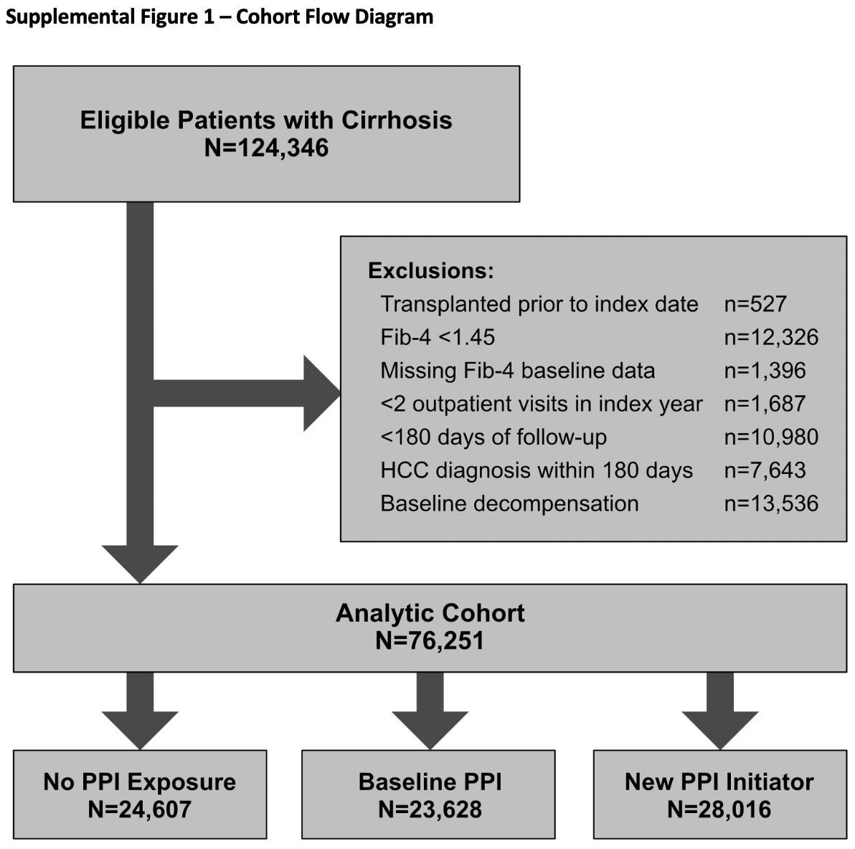

Although we used a well validated algorithm to determine cirrhosis decompensation, there is of course the possibility of some misclassification. To your point regarding further restriction of the cohort to Child-Pugh A patients, we agree that this is especially pertinent to the outcome of cirrhosis decompensation. Therefore, to address this critique, we have added a sensitivity analysis where we evaluated this outcome only among patients with initial Child-Pugh class A cirrhosis. We found that the association between PPI exposure and increased hazard of cirrhosis decompensation remained in this analysis, which is now included in the manuscript.
2. * Section-Design and Cohort Creation: page 4 line 32: As the purpose of the study is primarily to assess survival and decompensation in cirrhotic patients undergoing treatment with PPIs, it would be indicated to have a population with compensated cirrhosis only where at least 24 months of follow-up is available.

Response: Thank you for raising this issue. As noted in the response to your query #1, patients with baseline decompensated cirrhosis were in fact excluded from the study cohort—this is now corrected in the methods section, and Supplemental Figure 1 is included for further clarity. We excluded patients who had less than 6 months of follow-up data, however we also now detail overall follow-up time available in the cohort, as recommended in your query #6. These data are now shown in Table 1, stratified by PPI use categories. As an example, the median follow-up time available in patients on PPI at baseline was 52.2 months (interquartile range 27.9 to 81.4 months). We regard this to be sufficient to study the outcomes of interest on the timeline proposed in this study.
3. * Section-Study Design and Cohort Creation: page 4 line 36: to reduce the potential cirrhosis misclassification it could better to use as a criterion the presence of at least one of the following: i) previous liver biopsy showing stage 4 fibrosis by METAVIR score; ii) evidence of esophageal or gastric varices on esophagogastroduodenoscopy; iii) liver stiffness greater than 12 kPa on transient elastography.

Response: Thank you for this important critique. We agree that misclassification of cirrhosis is possible. Unfortunately, we do not have granular liver biopsy data for the cohort, and many patients with cirrhosis in the cohort have not received prior liver biopsy to establish METAVIR scoring. Similarly, we do not have readily available upper endoscopy results data or transient elastography reports—these would each require a natural language processing or manual adjudication approach to extract varices and kPa data given that reports are in a text format. This is unfortunately not feasible to perform for this manuscript given resource limitations. However, we would like to highlight that we have taken several measures to minimize cirrhosis misclassification in this regard. First, the presence of cirrhosis was determined using an algorithm that was previously manually adjudicated specifically in the Veterans Health Administration (VHA). This algorithm has been utilized in dozens of previously published studies in the VHA and is regarded to be highly accurate.,, To further refine the cohort, we did use a non-invasive fibrosis assessment—the Fib-4 score. We excluded patients with a Fib-4 <1.45 at baseline, which would argue against advanced fibrosis. To clarify the exclusions of patients, we have added a Supplemental Figure that details the formation of the final analytic cohort. Additionally, to address your important critique, we have expanded on the limitations section to highlight that cirrhosis misclassification remains a possibility that could result in selection bias in this study, and therefore the results must be interpreted cautiously in this context:

“Fifth, possible misclassification of cirrhosis could cause selection bias that therefore impacts the external validity of findings. Cirrhosis classification could be more definitively ascertained from liver histology or transient elastography data, which were not available in the present study. However, we feel that this bias is likely minimal given that we used a well-validated VHA algorithm to define the cirrhosis cohort and further excluded patients with low Fib-4 scores, a non-invasive marker used to classify patients with likely advanced hepatic fibrosis.”
4. * Section- Exposures: page 4 line 56 Considering that the diagnosis of NAFLD is essentially histological, it would be preferable to define this category as patients with liver cirrhosis associated with metabolic disorders or cryptogenic liver cirrhosis
Response: Thank you for raising this point. To address your comment we have changed “NAFLD” to “metabolic-associated fatty liver disease (MAFLD)” throughout the manuscript, consistent with expert consensus recommendations (PMID 32044314, now cited in the manuscript).
5. * Section- Exposures: page 5 line 1: please clarify whether all patients included in the study had a follow-up of 60 months
Response: Thank you very much for pointing out this issue; we agree that this warrants clarification. Not all patients had 60 months of follow-up, as many experienced the outcomes of interest prior to maximum possible follow-up, and others experienced loss-to-follow-up. We have clarified in the methods that the maximum follow-up window was 60 months for regression analyses. We have further clarified in the regression methodology that observations were right censored at liver transplantation, maximum follow-up, or (for non-mortality outcomes) at patient death. As per your suggestion in query #6 below, we have also included the median and interquartile range for overall follow-up data available for patients in the cohort.
6. * Table 1: please insert in the table the follow-up time expressed as median and range, anti-lipid-lowering agents and -anti-diabetic therapies.

Response: Thank you very much for this suggestion. We agree that these data would be useful. The median follow-up differ slightly for each of the outcomes studied (mortality, decompensation, infection, etc.). However, in Table 1 we now include the duration of overall patient follow-up time available for each PPI category (irrespective of the outcome). Regarding the addition of medications, we now include the proportion of patients taking statin medications at baseline, as well as antiplatelet agents at baseline. These are both relevant to subsequent analyses, as you have pointed out, as both are included as time-updating covariates in models. Unfortunately, we do not have anti-diabetic medications readily available for incorporation into this study. However, the presence of diabetes mellitus, BMI, CAD, CHF, etc. were all incorporated into inverse probability treatment weighting procedures, which we feel adequately address this issue.

Kaplan DE, Serper MA, Mehta R, Fox R, John B, Aytaman A, Baytarian M, Hunt K, Albrecht J, Njei B, Taddei TH. Effects of hypercholesterolemia and statin exposure on survival in a large national cohort of patients with cirrhosis. Gastroenterology. 2019 May 1;156(6):1693-706.
Mahmud N, Fricker Z, Hubbard RA, Ioannou GN, Lewis JD, Taddei TH, Rothstein KD, Serper M, Goldberg DS, Kaplan DE. Risk prediction models for post‐operative mortality in patients with cirrhosis. Hepatology. 2021 Jan;73(1):204-18.
Kaplan DE, Dai F, Aytaman A, Baytarian M, Fox R, Hunt K, Knott A, Pedrosa M, Pocha C, Mehta R, Duggal M. Development and performance of an algorithm to estimate the Child-Turcotte-Pugh score from a national electronic healthcare database. Clinical Gastroenterology and Hepatology. 2015 Dec 1;13(13):2333-41.
Saffo S, Kaplan DE, Mahmud N, Serper M, John BV, Ross JS, Taddei T. Impact of SGLT2 inhibitors in comparison with DPP4 inhibitors on ascites and death in veterans with cirrhosis on metformin. Diabetes, Obesity and Metabolism. 2021 Oct;23(10):2402-8.

